Orbital Wargame Overview

# Description

This document describes the high-level gameplay of the Orbital Wargame, including a “script” of the different decisions available to blue and red assets. The intent of this document is to describe the various options available to each asset so development can begin.

# Concept

This wargame involves a single blue spacecraft in GEO and multiple red spacecraft in orbits that bring them in relative proximity. As the scenario progresses the blue operator has opportunities to act based on the perceived threat from the red spacecraft. The blue operator uses FreeFlyer to view asset data in various plots and charts, which are realistically updated based on what data would actually be available in such a scenario.

In a future iteration, a red operator could have a similar set of plots and charts, and be given opportunities to select specific course of action. But for the initial version of the wargame there will be a few pre-scripted sets of red actions instead, so the wargame can be run at different levels of red hostility without requiring a dedicated red operator.

There will also be a white cell that has access to all of the data for all assets, to monitor execution of the wargame. At the end of the wargame the blue operator is assessed based on their performance.

# Red Script

The scenario contains four red assets, R1 through R4. R1 is in the neighboring GEO slot to the west of the blue spacecraft, B1. R2 is in a slightly lower altitude below the GEO belt, such that it transits from west to east between B1 the Earth. R3 is in a slightly higher altitude above the GEO belt, transiting from east to west and appearing behind B1 as viewed from the Earth. R4 is a small deployable spacecraft that is initially onboard R1. Basic depictions of these spacecraft are presented in figures 1a and 1b below from both top-down and nadir views of the Earth (neither figure is to scale and R4 is not shown since it is onboard R1).

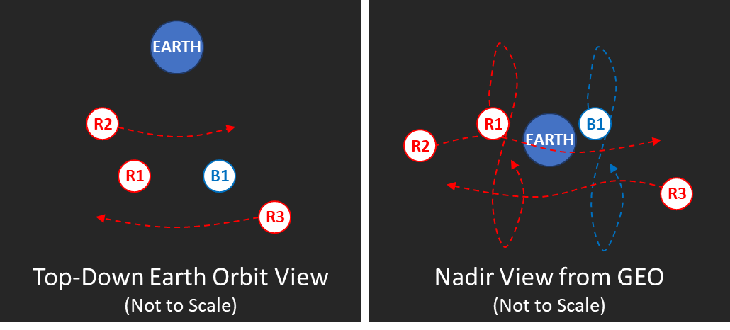  
Figures 1a & 1b: Red Asset Orbits

## Benign Script

When R1 reaches the eastern edge of its orbital slot it performs an east/west stationkeeping maneuver to maintain that slot and does not deploy R4. This is shown in figure 2 below. R2 and R3 progress in their orbits, transiting past B1 in opposite directions. The point of this script is to see if the blue operator does not take actions that unnecessarily escalate the situation or disrupt nominal operations.

Figure 2: Benign Script

## Observation Script

After the first day, R1 performs an approach maneuver that brings it within 20 km of B1 over seven days. At that point R1 maneuvers again to put it in an orbit that circumnavigates B1. After one day of circumnavigation, R1 maneuvers back to its orbital slot and continues GEO operations as normal. It does not deploy R4. The approach and circumnavigation maneuvers are shown below in figure 3.

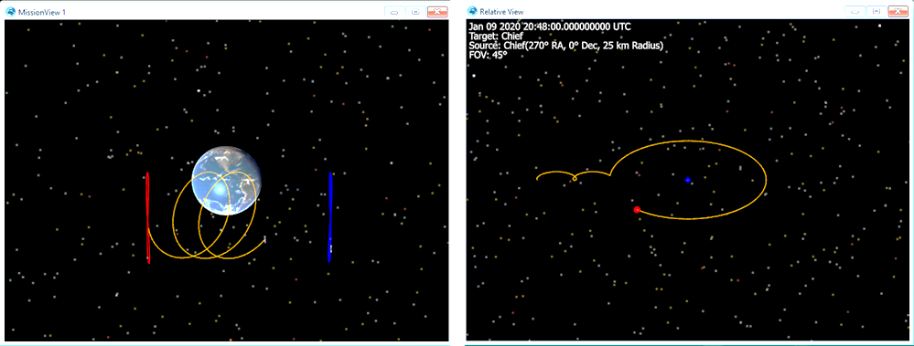  
Figures 3a & 3b: Observation Script

While R1 is circumnavigating B1, R2 and/or R3 use non-kinetic / electronic warfare means to disrupt communications and observations of B1 from the Earth. If the blue operator does not adapt to this disruption, they will not be able to communicate with B1 and they will not get regular updates on B1’s position. This persists until R1 has left the circumnavigation orbit of B1.

If B1 maneuvers unexpectedly or otherwise interferes with red’s operations, red will call off any further actions and return R1 to its orbital slot. The point of this script is to see if the blue operator properly recognizes that red is acting abnormally and reacts to disrupt red’s opportunities, without unnecessary escalation.

## Aggressive Script

R1 acts in the same manner as the Observation Script, but maneuvers more aggressively to bring it within 5 km of B1 after four days. At that point it deploys R4 which approaches B1, renders it inoperable, and returns to R1. Following recovery of R4, R1 returns to its orbital slot and continues GEO.

When R1 is two days away from circumnavigating B1, R2 and/or R3 begin their efforts to disrupt communications and observations between B1 and the Earth. This persists until R1 has returned to its orbital slot.

The blue operator will need to perform at least two actions (see section 4. Blue Script below for example actions) for red to call off its plans and return R1 to its orbital slot. The point of this script is to see if the blue operator recognizes the threatening nature of this scenario and acts appropriately to keep the blue spacecraft safe.

# Blue Script

Every twenty-four hours, the blue operator is given a set of actions they can take, which are listed below. The operator can only take one action at a time, so the actions should be a set of Multi-Choice elements in the FreeFlyer User Interface with Radio Buttons.

Blue Action Options:

1. **Continue Nominal Operations.** This means B1 will drift in its orbital slot, and perform a routine east/west stationkeeping maneuver when it reaches the far side.
   1. Impact on Observation Script: If this is selected for any of the turns while R1 is circumnavigating B1, red achieves their objective.
   2. Impact on Aggressive Script: If this is selected for any of the turns while R4 is deployed, red achieves their objective and B1 no longer shows up in the blue operator’s display.
   3. Impact to Blue operations: None.
   4. Impact to Red/Blue tension: None.
2. **Slew Attitude Away From R1.** This keeps sensitive payloads out of view from R1.
   1. Impact on Observation Script: If this is selected during the turn when R1 would nominally perform the circumnavigation maneuver, R1 will instead return to its orbital slot and fail to meet its objective. If this is selected the entire time R1 is circumnavigating B1, red will continue to follow the script, but fail its objective.
   2. Impact on Aggressive Script: None.
   3. Impact to Blue operations: Disrupted for each turn that this is selected.
   4. Impact to Red/Blue tension: No increase.
3. **Execute East/West Stationkeeping Maneuver.** This maneuvers B1 sooner than scheduled, using slightly more fuel in the long-term since the maneuver isn’t occurring at the optimal time.
   1. Impact on Observation Script: R1 will return to its orbital slot two hours after this occurs rather than expend additional fuel and fail its objective.
   2. Impact on Aggressive Script: Red will continue to follow the script, compensating for B1’s maneuver. However, if blue has selected the “Disrupt Red Observation” action (number 5, below) in the previous 48 hours, red will stop the script and R1 will return to its orbital slot. If R4 is unable to render B1 inoperable, red fails to meet its objective.
   3. Impact to Blue operations: Disrupted for the turn that this is selected.
   4. Impact to Red/Blue tension: Minor increase.
4. **Use Backup Communication and Observation Path.** If red has disrupted blue’s communications and observations the blue operator will not get regular updates on B1’s position and specific options will become unavailable. Namely, the Slew Attitude, Execute Maneuver, and Disrupt Red options would be grayed out. They can be selected again in the following turn, after this action is selected.
   1. Impact on Observation Script: None
   2. Impact on Aggressive Script: If this is selected while R2/R3 are trying to disrupt communications with B1 they will be thwarted and blue will have timely updates on B1 and all actions available.
   3. Impact to Blue operations: Disrupted for the turn that this is selected since it takes time to switch over to the other path.
   4. Impact to Red/Blue tension: None.
5. **Disrupt Red Observation via Electronic Warfare.** B1 interferes with the red assets in its proximity such that they can no longer properly observe B1. This requires more power than nominal operations, so it will only last for 48 hours and is unavailable after that.
   1. Impact on Observation Script: R1 will return to its orbital slot the turn after this occurs and fail its objective.
   2. Impact on Aggressive Script: Red will continue to follow the script, but not deploy R4 if that would normally occur during the 48-hour window. If blue executes the “Execute East/West Stationkeeping Maneuver” action (number 3, above) during the 48-hour window that this is active red will stop following the script and R1 (and R4 if deployed) will return to its orbital slot. If R4 is unable to render B1 inoperable, red fails to meet its objective.
   3. Impact to Blue operations: Disrupted for the turn that this is selected.
   4. Impact to Red/Blue tension: Major increase.

# Assessment

The operator’s actions are assessed to see if they acted in an appropriate and timely manner in response to red’s actions, without over or under reacting. They are graded on their impact to three criteria: red’s objectives, blue operations, and red/blue tension.

**Red’s Objectives.** The operator always gets 100 points for this criteria in the Benign Script. In the Observation Script the operator gets 100 points if red was unable to observe B1 while in the circumnavigating orbit, otherwise they get zero. In the Aggressive Script the operator gets 100 points if R4 was unable to disable B1 by the end of the scenario, otherwise they get zero.

**Blue Operations.** The operator grade starts at 100 and they lose 10 points for each turn where blue operations were disrupted. Note that when running the Observation and Aggressive Scripts this will be less than 100 in order to stop red from achieving their objective. In the Aggressive Script, if B1 is rendered inoperable this score goes to zero.

**Red / Blue Tension.** The operator grade starts at 100 and they lose 10 points for each minor action and 25 points for each major action. Note that when running the Observation and Aggressive Scripts this will be less than 100 in order to stop red from achieving their objective.

At the end of the game the white cell will provide context along with the numeric assessment so it is clear what the operator could have done better, if anything.

# Sample Decision Tree

Figure 4 below is a quick mock-up of the decision tree for the Observation Script that shows the blue operator’s major decision points. There is more than what’s shown here, but the intent is to describe a few different ways the game could go.

Figure 4: Observation Script Decision Tree

Each endpoint states whether red succeeds or fails to meet its objective and lists the assessment score in parentheses. For example, if blue slews B1 to avoid direct observation by R1 during its circumnavigation orbit the score is 100 (red failed to meet their objective), 90 (blue lost a day of operations because they were slewed), 100 (no impact to red/blue tensions) resulting in the highest possible total score of 290. The assessment scheme described in Section 5 can be adjusted so these scores align well with what would objectively be considered better or worse results.